7 reasons why ABC’s Barracuda

is great Aussie TV

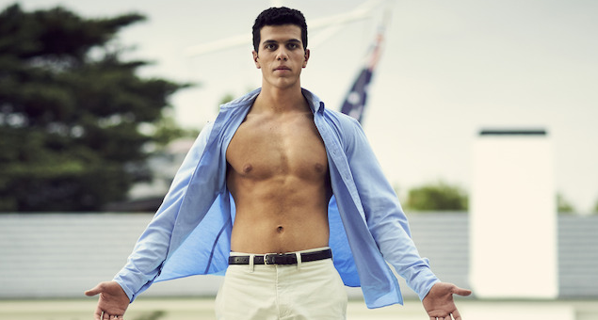

 by Glenn Dunks

Tue 19th Jul, 2016 in Features
The ABC is mid-way through its four-part mini-series, Barracuda. It follows a young Melburnian high schooler, Danny (Elias Anton), with dreams of Olympic gold in the pool and the lengths he will go to get it.
If you’ve been watching along on Sunday nights then you may not be able to believe that it actually gets even better, but it does. So much better.
If you missed it, however – or if you just can’t hold on any more and need to know what happens –ABC’s online streaming platform iView has the entire series up to watch online.

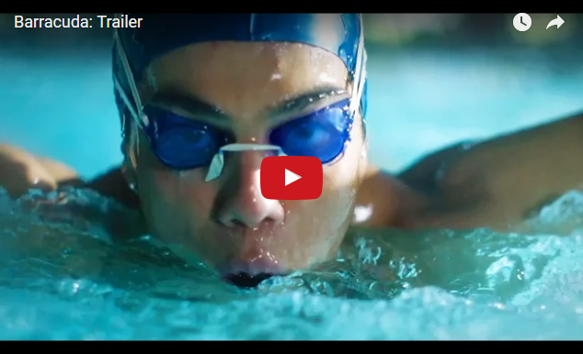

1. LGBT Youth on Screen
It is rare to see Australian television treat issues about LGBT youth so seriously and not just background filler on soap operas. Danny is far from a role model, but youth who do not identify as straight need characters like this that reflect a wider world-view. And in lead roles too! The series is potent and poignant and many LGBTQI audiences will get a lot of Danny’s struggle. It’s a show full of melancholy about the experience of a missed opportunity at love and life.
Barracuda doesn’t have the time to get into Danny’s sexuality quite as much as the novel, but by the impeccable, flawless final episode there’s no masking how vital it can be to audiences who are not used to seeing portrayals like this.
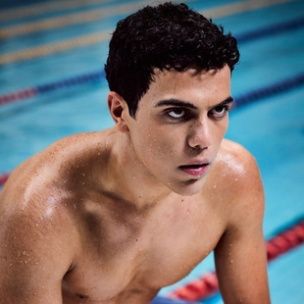
2. Race and Class
For as much as Barracuda is a show about a young gay man, it is equally interested in topics of race and class. Danny comes from a Greek working-class family making his way into the world of private schools and the wealthy, predominantly white families that populate them whose arguments revolve almost exclusively around money. His newfound shame over his dad’s truck driving job surfaces regularly and he’s eager to make sure his mum knows she’s not like the other mums.

All of this is to be expected given it’s adapted from a novel by Christos Tsiolkas. He also wrote Loaded, which was later adapted into the seminal gay flick Head On in 1998 that officially turned Alex Dimitriades into the iconic gay fantasy of the ‘90s.

3. A Sporting Country
Despite our reputation as a sporting nation, Australian film and TV rarely offers audiences anything that gets the sensations, the excitement, and the heightened emotions of sport so spot on. The swimming sequences, gorgeously filmed as they are, will no doubt get the blood pumping.

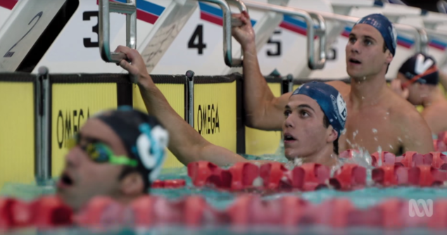
4. Speedos Galore

Speaking of getting the blood pumping. You won’t have seen this many fit guys in speedos outside of your last trip to Bondi. Is this the reason it is set in 1998 and not 2016? Full body swimsuits just don’t have the same… aesthetic appeal, you know?

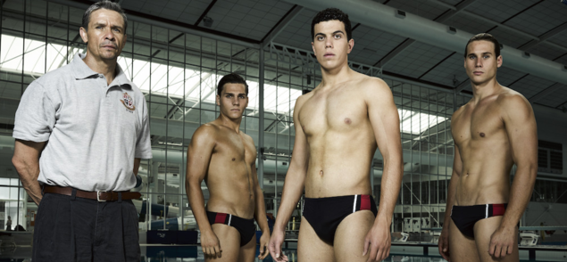

5. Elias Anton and Ben Kindon

Meet two of your favourite new local actors. Both newcomers, they more than make themselves at home with the material, offering sobering portrayals of conflicted, confused, and confounded teenagers whose minds are a swirl of testosterone, shame, selfishness, embarrassment, anger, pettiness, sex, and even kindness. So, a normal teenager then.

As rivals and then best friends, these two actors more than hold their own against the adult stars including Rachel Griffiths, former rugby star-turned-actor Matt Nable, Damon Gameau, and a particularly heartbreaking Victoria Haralabidou as Danny’s mother.

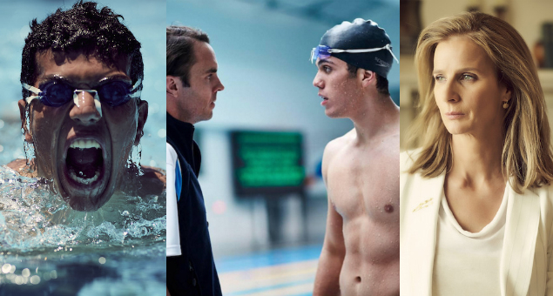

6. A Finale for the Ages

The entire series of Barracuda is very good, but – as I have alluded to already – the finale episode is truly one of the best hours of television Australia has produced. It is powerful, heart-breaking stuff that will make you simultaneously wish for four more episodes while acknowledging that it was the perfect way to end.

Why we need debates about diversity on screen when episodes of TV like this, a story we’ve truly never seen realised on screen before and which wouldn’t work if about straight, white people, prove it is essential.

7. “I did it for you.”

When Danny leaps out of the pool at the episode of the second episode having won his race in world record time and sending him to the Olympics, he hugs his best mate and says “I did it for you.” It’s a striking moment and takes the characters and the audience by surprise. It’s a “I wish I knew how to quit you” for a new generation.

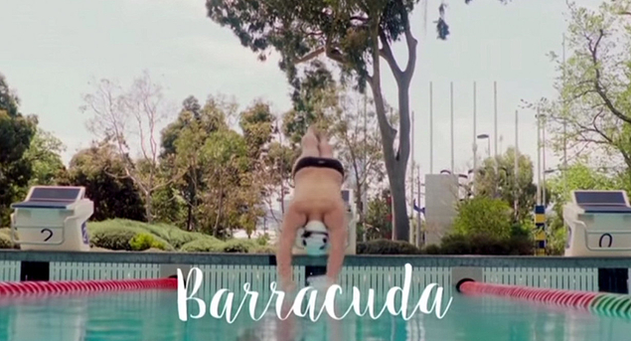

Barracuda airs Sunday nights at 8.30pm on ABC, and is streaming in full on iView.

